DC总线烟雾探测器介绍

系统总览
此烟雾探测器(DC-SD) 网络设计用来满足欧洲的7FP Scarlett 项目的一部分.此系统是基于 SIG60 和 SIG61 两颗芯片. 此芯片在一些列的传感器和执行器器之间通过DC总线技术在电源线上通信,减少线束的尺寸和重量,继而减少安装难度.

The DC-SD can connect up to 16 nodes per network. Several networks may operate simultaneously over the same DC powerline, using different carrier frequencies. The DC-SD demonstrator in SCARLETT consists of four smoke detectors. Two versions of devices are used in the DC-SD;

The SIG60 operates as a general purpose DC powerline UART transceiver used by the Master unit to communicate between the RDC and variety of remote sensors and actuators such as the smoke detectors. The device has most of the circuitry required for proper operation, occupying very small foot print. The device operates either as the bus master or as a slave.
The SIG61 device operates as smart slave with built-in eight output ports and eight input ports(8个输入输出脚). Each device has its own configured address. The device receives a Write command from a Master (SIG60) to activate its output pins. The Read command from the master reads the status of its eight input pins and sends it as a digital data back to the master. Each of the DC-SD’s has the device as its main building block.

for redundancy
DC-SD 1
DC-SD 2
DC-SD 3
DC-SD 4
RDC
DC-BUS
Master Unit
DC Power line
Data Out
Data In
UART Interface
Figure 2.1 – 烟雾探测器网络模块图

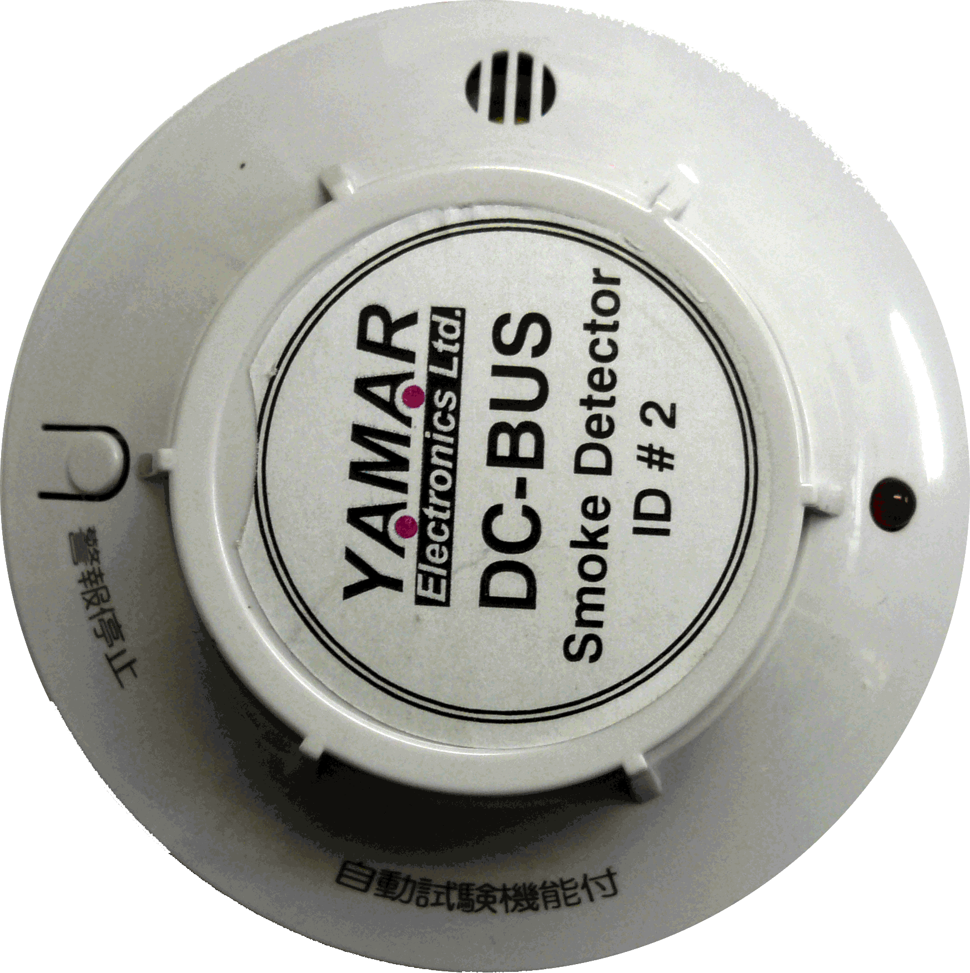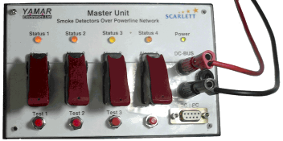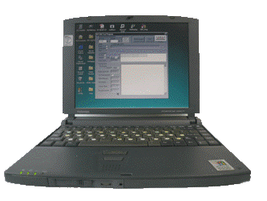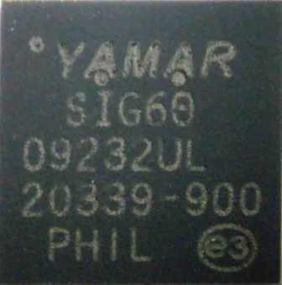
For redundancy
DCB-SD Master
Host (optional)
Smoke Detectors DC-BUS
network
Sprinkle
Figure 2.1a – 烟雾探测器系统

The SIG60 modules and the SIG61 Independent Slave modules are built to interface between any uC and its sensors and actuators. Both are based on the corresponding semiconductors devices: The simple UART interface allows transmission of any number of bytes with a fixed latency of 3.5 bits.

A Sleep mode saves power when device is not used. Wakeup messages on the DC line awaken remote devices.

The SIG60 device is designed to overcome the hostile communication conditions of a avionic power line. It consists of a unique DC-BUS Modem, Coder/Decoder and a Communication Controller overcoming the hostile environment over vehicle battery lines. Sleep mode reduces the power consumption when there is no bus activity.

The switching power supply provides the 3.3V voltage required for the DC-SD operation. The power supply operates in a wide input voltage range between 10V and 32V. The module current consumption is in the range of 30mA.

主控制单元
主控单元支持4个烟雾探测器, 通过测试和报警功能来控制每个烟雾探测器.
测试键发送一个信息给对应的1到4个烟雾探测器来测试其工作. As a result, a sound indication will be activated on the SD and as a result, the SD will return to the Master Unit with a Fire Status indication that will activate the Status LED to RED.
The Alarm function activates in the SD a signal that can activate any general purpose output such as Fire distinction device or an emergency light.

The Master Unit has one bi-color status LED for each of the SDs. The Status LED has three indications.
RED – Indicates fire detection in the corresponding SD.
GREEN – Indicates proper operation of the SD in the network.
YELLOW BLINKING – the SD was not detected in the network.
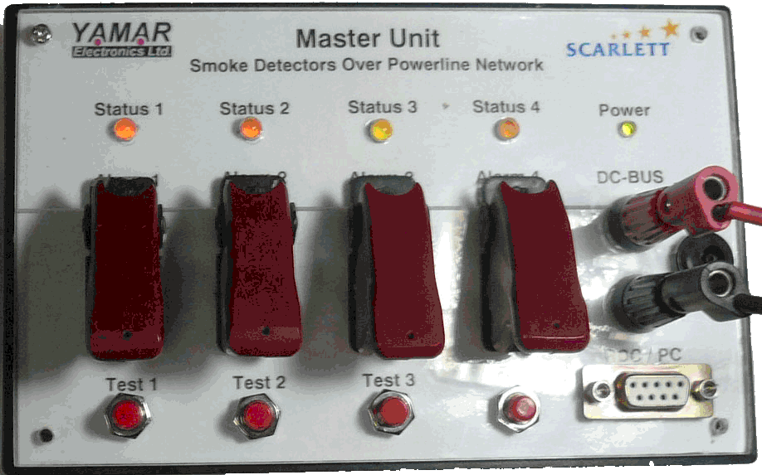
Figure 3.1 – 主控单元面板

DC-BUS
DC-SD
Master
Alarm1
Alarm2
Alarm3
Alarm4
Status1
Status3
Status4
Test1
Test2
Test3
Test4
SIG60
Power
Supply
Status2
Figure 3.2 - DC-SD 主控单元硬件

主要特性
- Single wire for Power and Communication Reduce wiring complexity, weight and cost
- Master – Slaves operation
- Up to 56.7Kbps per channel
- Simple UART communication protocol
- Small footprint (size)
- Optional other networks over same powerline using different carrier frequencies

从控制单元
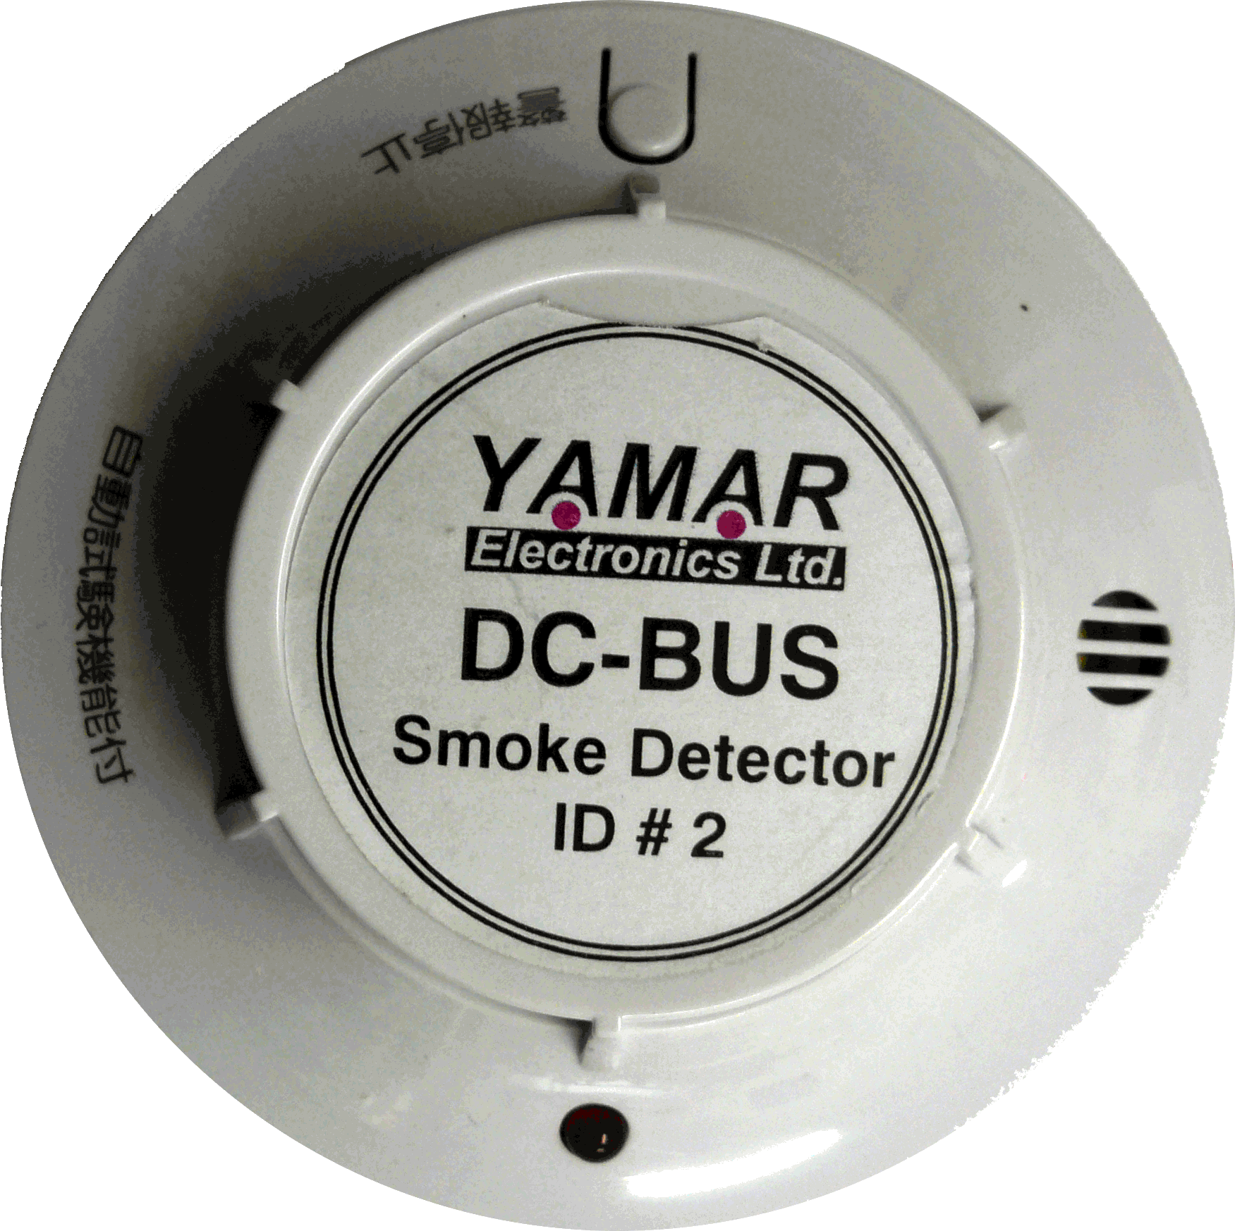
Test
Alarm
Status
Smoke
Detector
DC-BUS
Power Line
Power
Supply
Figure 4.1 – 烟雾探测模块图

A SD module contains the electronic Smoke detection circuitry, sound alarm and a test switch. A SIG61 device senses the SD output periodically (every 50mS). If smoke is detected, the Master Unit gets this indication. The Master unit can activate the SD test function as well as the Alarm general purpose output

The SD operates from the DC-BUS line using 10V to 36V switching mode power supply module.

Pushing the Test button on the SD generates a Sound alarm on the local SD and activates the corresponding status indication in the Master Unit.
Figure 4.2 – SIG61模块

SIG61DC-总线芯片在I/O外围设备单线吵杂信号通信网络或者一个DC电力线通信的一个从设备,一个SIG60芯片作为主设备来控制SIG61芯片. The independent slave is an economical solution for network of multiple slave devices in applications as controlling motors, reading sensors etc., eliminating the need for a dedicate controller for slave modules.

Five types of messages may be transmitted to each one of the SIG61 slaves; Read, Read Change, Write, Sleep and Change Frequency. The SIG61 slave device identifies a dedicated message addressed to its predefined ID pins (Similar to the LIN protocol). When a Write message is received, the data part of the message is directed to its corresponding 8 output pins. When a Read or Read Change message is detected, the slave responds with a message that contains information of all its 8 inputs. A Sleep command enables power saving. Wakeup messages awaken remote devices.

Smoke
Detector
Alarm
DC-BUS
Power line
Figure 1.4 – 烟雾探测器模块图

Figure 1.5 - DC-SD Master Figure 1.6 - Smoke Detector module

安装
- 如图2.1那样连接烟雾探测器,烟雾探测器的顺序不重要
- 将烟雾探测器相互连接
- 将两端连接到DC-BUS口.
- 连接12V供电到DC-BUS口或者连到靠近接口的DC连接器.

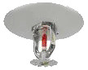
用于冗余
DCB-SD Master
Host (可选)
烟雾探测器 DC-BUS
network
洒水
洒水
图2.1 – 烟雾探测器系统

电气参数

Absolute Maximal Rating
Ambient Temperature -40°C to 125°C
Storage Temperature -55°C to 150°C
Input Voltage -0.6V to Vcc+0.3V
Vcc Supply voltage -0.3V to 4V

Module Electrical Operating Conditions
Symbol | Characteristics | Min | Typ | Max | Units | Conditions
Vbat | Supply Voltage | 10 |  | 32 | V
Ic | Supply Current |  | 30 |  | mA | 28V
Ipd | Power in Sleep mode |  |  | 100 | uA

工作温度
Commercial: 0°C to 70°C
Industrial: -40°C to 85°C

